Implementing the Singleton Pattern :
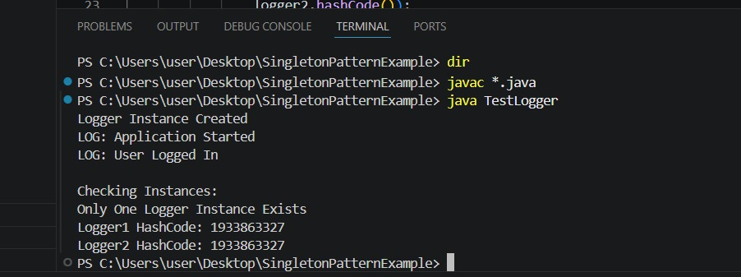
Implementing the Factory Method Pattern :
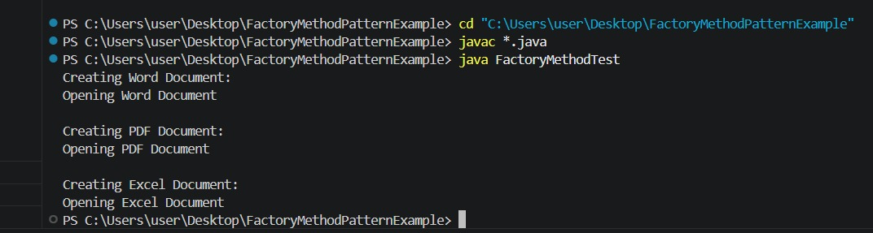
Implementing the Builder Pattern :
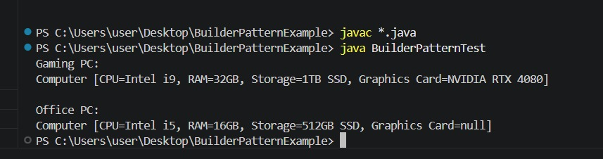

Implementing the Adapter Pattern :
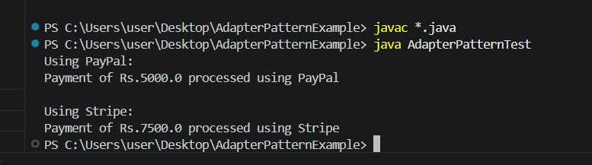
Implementing the Decorator Pattern :
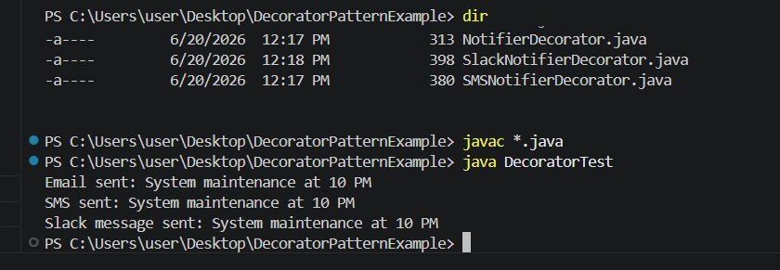
Implementing the Proxy Pattern :
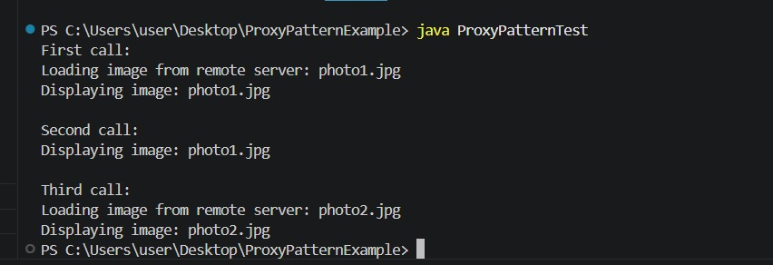

Implementing the Observer Pattern :
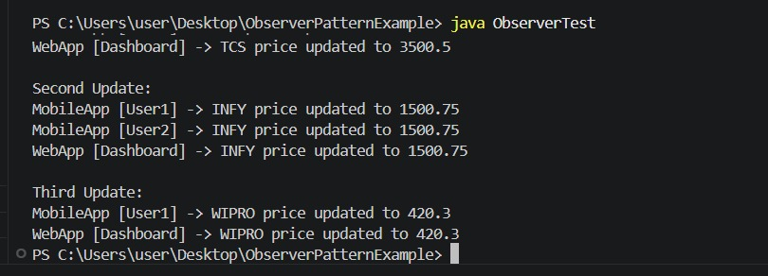
Implementing the Strategy Pattern :
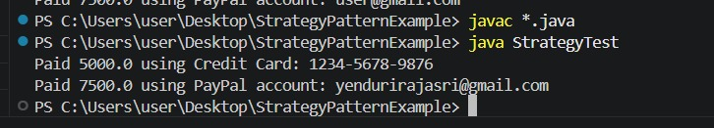
Implementing the Command Pattern :
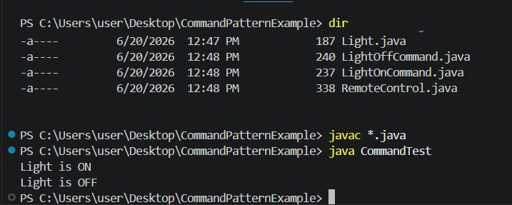

Implementing the MVC Pattern :
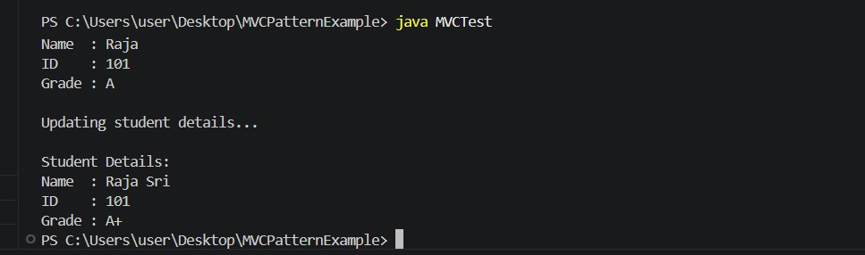
Implementing Dependency Injection :
